Bayaan Lagu diiddan yahay Gudniinka Fircooniga ah ee Gabdhaha, oo ka yimid Dawladda Skotland
Waa maxay FGM ama Gudniinka Fircooniga ah ee Gabdhuhu?
FGM waxay tilmaamaysaa hawl kaste oo qayb ahaan ama gebi ahaan lagu saaro qaybta dibadda ee saxaaxa haweenka ama dhaawac kale oo loo geysto xubnaha saxaaxa ee haweenka iyadoo sababtu aanay caafimaadka ahayn.
FGM waxaa weliba loo yaqaannaa 'sarista' iyo 'gudista haweenka' waxaana mararka qaar lagu sheegaa 'sunne', inkaste oo aanay jirin diin rukhsaysay FGM.
FGM waa caado dhaqameed oo waxyeello leh. Gabdhaha qaarkood waxay u dhintaan dhiigbax ama bukaansho ama jeermis gala kuwaasoo si toos ah uga yimaadda FGM. Haweenku waxay noloshooda oo dhan yeelan karaan dhibaatooyin caafimaadeed waxayna FGM dhibaatooyin u keeni kartaa ilmo dhalista. Ma jiraan faa'iidooyin caafimaadeed oo ay FGM leedahay.
Shuruucda Skotland iyo Ingiriiska
FGM waa dembi Skotland dhexdeeda iyo Ingiriiska gebi ahaantiis (1). Waxaa weliba dembi ah in qof uu sameeyo, caawiyo ama qaban qaabiyo gudniinka FGM ee qof kale, xataa haddii gudniinka laftigiisu uu ka dhaco meel Skotland ka baxsan.
(1) Skotland gudaheeda waa sharci darro marka la raaco Sharciga Mamnuucidda Gudniinka Fircooniga ah ee Gabdhaha (Skotland) ee 2005 soo baxay (Prohibition of Female Genital Mutilation (Scotland) Act 2005). England, Wales iyo Waqooyiga Ayrland gudahooda, caadadu waa sharci darro marka la raaco Sharciga Gudniinka Fircooniga ah ee Gabdhaha ee 2003 soo baxay (Female Genital Mutilation Act 2003).
Ciqaabaha Dembiyeed
Qof kaste oo lagu soo helo dembiga FGM – ama caawinta iyo dhiirrigelinta dembiga noocaas ah – waxaa ku wajahan ciqaab ilaa 14 sano oo xabsi ah, ganaax, ama labadaba.
Gargaar iyo Taageero
Haddii aad Ingiriiska joogto oo aad ka walwal qabto in ay taasi adiga kugu dhici karto ama ku dhici karto qof aad garanayso, waxaad la hadli kartaa macallin, takhtar, kalkaaliyaha caafimaadka ee dugsiga, hawlwadeen bulsheed (social worker), askari booliis ama xirfadle caafimaadeed, waxbarasho ama daryeelka bulsheed. Iyaga ayaa ku caawin kara oo ku taageeri kara.
Waxaad weliba wici kartaa hay'adda NSPCC ee badbaadinta carruurta oo aad ka helayso lambarka 0800 028 3550. Kani waa khad caawin oo 24 saacadood furan oo loogu talagalay qof kastoo ka walwal qaba gabdhaha ama haweenka halis ugu jira FGM.
Haddii aad Ingiriiska joogto oo aad halis dhow ugu jirto, ama aad ka walwal qabto in dalka dibaddiisa lagu geyn karo si laguugu sameeyo gudniinka FGM, fadlan booliiska la xiriir oo wac lambarka 999.
Haddii aad dalka dibaddiisa joogto oo aad u baahan tahay gargaar ama talobixin fadlan wac Xafiiska Arrimaha dibadda iyo Barwaaqosooranka (Foreign and Commonwealth Office) oo aad ka helayso lambarka +44 (0) 20 7008 1500 ama Hay'adda (High Commission) ama Safaaradda Dawladda Ingiriisku ay ku leedahay waddanka aad booqanayso.
Xiriirrada
SI AAD WARBIXIN DHEERAAD AH U HESHO TAG HALKAN
www.fgmaware.org
Ama la xiriir ururradan:

DIGNITY ALERT RESEARCH FORUM (GOLAHA CILMIBAARISTA DIGTOONAANTA SHARAFEED) (DARF)
Ololaha iyo shaqada waxbaridda ee lagu afjarayo gudniinka FGM.
dignityalert@hotmail.co.uk
www.darf.org.uk

WOMEN’S SUPPORT PROJECT (MASHRUUCA TAAGEERADA HAWEENKA)
Warbixin iyo ilo ku saabsan FGM, iyo macluumaadka ururrada gargaar bixin kara.
0141 418 0748
wsproject@btconnect.com
www.womenssupportproject.co.uk/vawtraining/content/resources/234/

SHAKTI WOMEN’S AID (GARGAARKA HAWEENKA SHAKTI)
Taageerada haweenka iyo carruurta la kulma xadgudubka guriga ama guurka khasabka ah.
0131 475 2399
info@shaktiedinburgh.co.uk
www.shaktiedinburgh.co.uk

AMINA: KHADKA CAAWINTA HAWEENKA MUSLIMIIN AH
Taageero iyo warbixin haweenka arrin kaste laga siiyo.
0808 801 0301
info@mwrc.org.uk
www.mwrc.org.uk

Ujeeddada bayaankani waxay tahay in lagu caawiyo sidii gabdhaha looga badbaadin lahaa Gudniinka Fircooniga ah ee Gabdhaha (Female Genital Mutilation) (FGM).
Ku dhex hayso baasaboorkaaga ama boorsada yar ee haweenka ama boorsada jeebka ee aad waqti walba sidato – gaar ahaan marka aad dalka ka baxdo. Waxaad kan tusi kartaa qoyskaaga, saaxiibbadaada iyo qaraabadaada. Bayaankani waxuu si cad u tilmaamayaa in gudniinka FGM uu dembi xun ka yahay Skotland iyo Ingiriiska oo dhan, iyadoo qofkii kastee dembiga lagu soo helo la saari doono ciqaab ugu badnaan ah 14 sano oo xabsi ah.

Bayaankan waxaa taageersan Wasiirrada Skotland, Sarkaalka Sare ee Caddaaladda (Lord Advocate) iyo Booliiska Skotland

Saxiixyada

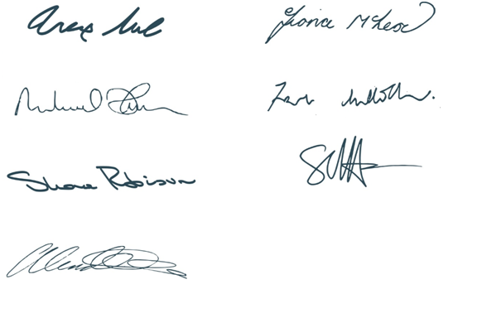  Mr Alex Neil  Cabinet Secretary for Social Justice Communities  and Pensioners Rights | Ms Fiona McLeod  Minister for Children and Young People
Mr Michael Matheson  Cabinet Secretary for Justice | Mr Frank Mulholland QC  Lord Advocate
Ms Shona Robison  Cabinet Secretary for Health | Sir Stephen House QPM  Chief Constable, Police Scotland
Ms Angela Constance
Cabinet Secretary for Education and
Lifelong Learning

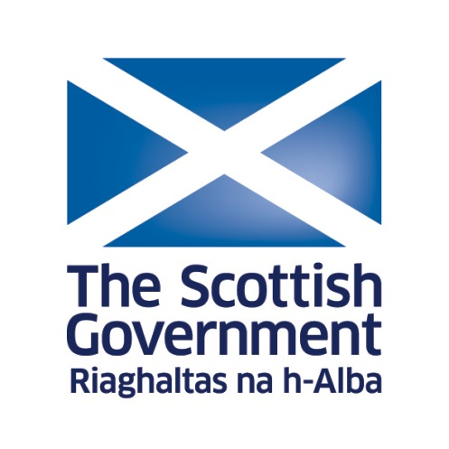
Scottish Government statement opposing Female Genital Mutilation: SOMALI

